

VOYAGER

ECS3001 - Engineering Clinics – II
PROJECT REPORT

BY:
Changela Vivek Vimalbhai (23BCE8743) - CSE
Amey Rasekar (23BCE8587) - CSE
Darin Joseph (23BCE7919) - Spec. in Cyber Security
Jahnavi Naidu (23BCE8395) -CSE core
Nanduri Srikari (23BEC7140) - Minor in Data Analytics
Dipti Bankar (23BEC7131) - Spec. in VLSI

Faculty: Prof. Swati Shukla (SENSE)

2024 -2025

TABLE OF CONTENTS

Chapter No. | Title | Page No.
1 | Abstract | 3
2 | Introduction | 4
3 | Background | 5
4 | Problem Definition | 7
5 | Objectives of the proposed work | 8
6 | Methodology/Procedure | 9
7 | Results and Discussion | 11
8 | Conclusion and Future Scope | 12
9 | References | 13
 | Appendix I - Source Code/prototype visuals | 14-20

Abstract:
The need for safer, more affordable, and efficient underwater exploration is increasing, especially as traditional methods involving divers and large vessels can be risky, expensive, and not always practical. To address these issues, the VOYAGER project focuses on developing a small-scale Remotely Operated Vehicle (ROV) that can perform real-time underwater navigation using embedded systems and wireless communication.
VOYAGER is designed as a compact and modular underwater vehicle that can be directly controlled by a user. It uses an ESP32-based controller to handle communication, motor functions, and data processing. The vehicle moves forward and backward using DC motors, while a servo mechanism helps it change direction smoothly. The overall design is simple and reliable, making it suitable for testing in controlled environments like water tanks and shallow water.
One of the key features of VOYAGER is its onboard camera, which captures underwater video and sends it wirelessly to the operator. This allows the user to see and control the vehicle at the same time, improving ease of use. The system avoids complicated wired connections, making it more flexible. In addition, the project explores the idea of wireless charging to reduce the need for exposed charging ports and improve durability.
Key highlights:
- Real-time control and navigation
- Live video streaming for better visibility
- Simple motor and steering mechanism
- Compact and cost-effective design
- Wireless communication for easy operation
- Concept of wireless charging for improved safety
Overall, the VOYAGER project provides a simple and practical way to understand underwater robotics while addressing basic challenges in underwater exploration

Introduction:

Underwater environments are still largely unexplored because they are difficult and risky to work in. Challenges like high pressure, poor visibility, and limited human access make exploration expensive and complex. Traditional methods using divers or large vessels are not always practical, which is why projects like VOYAGER focus on building smaller, smarter, and more efficient underwater systems.
The VOYAGER system is designed as a simple and compact underwater vehicle that can perform real-time navigation and monitoring. It combines different technologies to make operation smooth and reliable, such as:
- A compact and modular design that is easy to handle and test
- An ESP32-based controller to manage all system operations
- Integration of communication, motor control, and data processing
- DC motors for forward and backward movement
- A servo motor for smooth and controlled steering
- Stable navigation suitable for tanks and shallow water environments
To make the system easier to operate, VOYAGER also focuses on real-time monitoring and wireless control:
- Wireless communication using Wi-Fi
- Real-time control by the user
- An onboard camera for capturing live underwater video
- Continuous video streaming to the operator
- Better visibility and control during operation
- No need for complex wired (tethered) connections
- Improved flexibility and ease of use
Durability and maintenance are also considered in the design:
- Concept of wireless charging for safer power transfer
- Avoidance of exposed charging ports
- Better waterproofing and protection
- Reduced maintenance effort
- Improved reliability over time
Apart from functionality, the project also acts as a learning platform:
- Combines embedded systems, electronics, and mechanical design
- Involves real-time communication system integration
- Provides hands-on experience with system design
- Shows how hardware and software work together
- Helps in understanding practical engineering challenges
So far, the VOYAGER prototype has successfully shown its basic capabilities, including:
- Smooth movement and propulsion
- Accurate steering control
- Stable wireless communication
- Real-time video streaming
Overall, VOYAGER offers a simple, practical, and effective approach to underwater robotics, while also providing a strong base for future improvements and real-world applications.

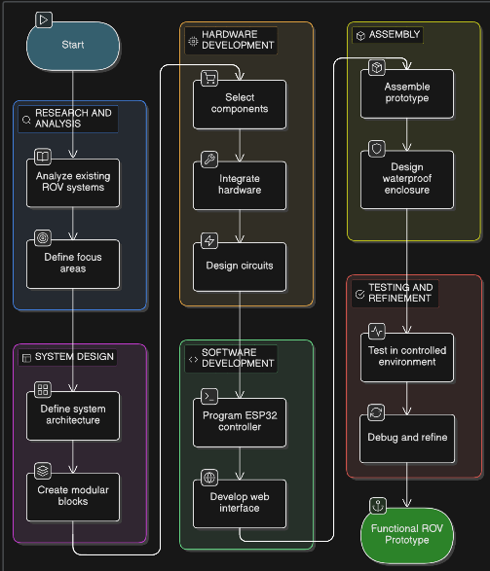

Background:
Underwater exploration plays an important role in areas like marine research, environmental monitoring, and industrial inspection. However, it is still difficult due to challenges such as high pressure, low visibility, and limited human accessibility. Traditional methods using divers and large submersibles are often risky, expensive, and not very flexible, which has led to the need for safer and more efficient alternatives.
In earlier approaches, underwater tasks were mainly carried out by human divers and large manned systems. While these allowed direct interaction, they were limited by depth restrictions, safety concerns, and high operational costs. This led to the development of unmanned underwater systems, which improved safety and efficiency.
These systems are mainly of two types:
- Autonomous Underwater Vehicles (AUVs), which operate independently but require complex programming and advanced components
- Remotely Operated Vehicles (ROVs), which are controlled by a user and provide real-time feedback, making them simpler and more practical
ROVs are widely used because they are easier to control and suitable for applications like inspection, monitoring, and learning purposes.
With recent advancements in technology, building small-scale ROVs has become easier. Modern systems use compact controllers like ESP32, along with affordable motors, sensors, and cameras. These components allow the development of lightweight and cost-effective underwater vehicles.
Communication and durability are also important challenges in underwater systems. Wireless signals are weaker in water, so many systems rely on wired connections, though short-range wireless communication can still work in shallow environments. At the same time, proper sealing and design are necessary to prevent water damage and ensure long-term reliability.
The VOYAGER project is developed based on these ideas, focusing on creating a compact and functional underwater ROV. It supports controlled movement, real-time communication, and live video feedback, while keeping the design simple, practical, and suitable for learning and experimentation.

Problem Definition:

The development of small-scale underwater robotic systems presents several practical challenges that limit their efficiency, reliability, and ease of use. While existing Remotely Operated Vehicles (ROVs) demonstrate basic functionality, they often fall short in terms of robustness and user convenience, especially in student-level implementations and controlled environments.

The VOYAGER project is motivated by the need to address the following key problems:
- Limited Accessibility of Underwater Exploration
Traditional methods such as human diving and large submersibles are costly, complex, and not feasible for small-scale or academic applications.
- Complexity in Existing ROV Designs
Many available systems either rely on tethered communication or involve complex architectures, making them difficult to deploy and operate in simple environments like tanks or shallow water bodies.
- Unreliable Power and Charging Mechanisms
Conventional ROVs use wired charging systems that:
  - Require opening sealed enclosures, increasing risk of water leakage
  - Include exposed connectors prone to corrosion and damage
  - Reduce long-term durability and reliability of the system
- Maintenance and Operational Inefficiency
Frequent handling of internal components for charging and repairs leads to:
  - Increased wear and tear of sealing mechanisms
  - Higher chances of component failure
  - Reduced ease of repeated deployment
- Lack of Compact and Modular Prototypes
Many systems are not optimized for modularity, making upgrades, testing, and scalability difficult in academic projects.
- Need for Real-Time Monitoring and Control
Efficient underwater navigation requires:
  - Reliable real-time communication
  - Live visual feedback for operator decision-making
  - Stable control mechanisms for precise movement

Objective of the proposed work:

The VOYAGER project aims to design and develop a compact, efficient, and reliable Remotely Operated Underwater Vehicle (ROV) that demonstrates the practical application of embedded systems and wireless communication in underwater environments. The objectives are structured to focus on both functional implementation and addressing real-world engineering challenges identified in existing systems.
The primary objectives of the proposed work are as follows:

- To design and develop a functional underwater ROV prototype
Build a compact submarine-like system capable of operating in controlled underwater environments such as tanks and shallow water bodies.
- To implement controlled underwater navigation
Achieve forward and backward movement using DC motors and enable directional control through a servo-based mechanism for effective maneuverability.
- To establish real-time wireless communication
Develop a Wi-Fi-based control system that allows the operator to send commands and receive system feedback in real time without the use of tethered connections.
- To integrate a live visual monitoring system
Utilize an onboard camera module to capture and transmit real-time video, enabling the operator to monitor underwater conditions and navigate accordingly.
- To develop a compact and modular embedded system architecture
Ensure that the system design is organized, scalable, and easy to assemble, making it suitable for academic prototyping and future enhancements.
- To improve system reliability and waterproof integrity
Design the system with a sealed enclosure and minimize physical exposure of sensitive components to water, thereby enhancing durability and operational safety.
- To incorporate an advanced power management approach
Implement a wireless charging concept to eliminate the need for exposed charging ports and reduce mechanical handling of the enclosure.
- To demonstrate practical integration of multiple engineering domains
Combine concepts from embedded systems, electronics, communication, and mechanical design into a single cohesive working prototype.
- To create a foundation for future enhancements and scalability
Develop the system in a way that allows additional features such as improved control systems, extended communication range, or advanced sensing capabilities to be integrated in future iterations.

Methodology/Procedure:

The development of the VOYAGER ROV followed a structured and step-by-step approach, focusing on building a system that is simple, reliable, and practical for real use. The process combined design, component integration, and testing, making sure the prototype could be developed effectively within a student-level framework. The entire procedure moved gradually from initial design to final testing and improvement.
Initially, existing small-scale ROV systems were studied to understand how they work and what limitations they have. This helped in identifying important focus areas such as compact design, wireless control, real-time monitoring, and better power management. Based on this, a clear direction for the system design and component selection was established.
The next stage involved system design and planning, where the overall structure of the ROV was divided into major functional parts:
• Processing and communication unit
• Propulsion and control system
• Power management system
• Visual data (camera) system
This modular approach made the design easier to understand and helped in smooth integration of all subsystems.
After the design phase, component selection and hardware integration were carried out. The ESP32 module was chosen as the main controller because of its built-in Wi-Fi and good processing capability. DC motors were used for movement, and a servo motor was used for steering. A motor driver was connected to control the motors, and a camera module was added for live video capture. All components were arranged carefully inside a compact structure to ensure stability and proper wiring.
The circuit design phase involved connecting all components properly and managing power distribution. A DC-DC boost converter was used to maintain a stable voltage supply for all parts of the system. Care was taken to organize the wiring neatly to avoid interference, loose connections, and power issues.
At the same time, software development was carried out using the ESP32. The system was programmed to:
• Control motor movement (forward and backward)
• Operate the servo for direction control
• Set up Wi-Fi for wireless communication
• Enable real-time video streaming from the camera
A simple web-based interface was also developed so that the user could easily control and monitor the system.
Once both hardware and software were ready, the prototype was assembled and enclosed. The enclosure was designed to securely hold all components while maintaining proper waterproofing. Extra care was taken to ensure sealing and structural stability for safe underwater operation.

The final stage involved testing and improvement. The system was tested in controlled environments to check:
• Movement and motor performance
• Steering and navigation
• Stability of wireless communication
• Quality of video streaming
Based on the test results, necessary changes were made to improve performance, fix minor issues, and increase reliability.
In addition, the idea of wireless charging was explored as part of the design. Although not fully implemented, it was considered to reduce the need for exposed charging ports and improve durability.
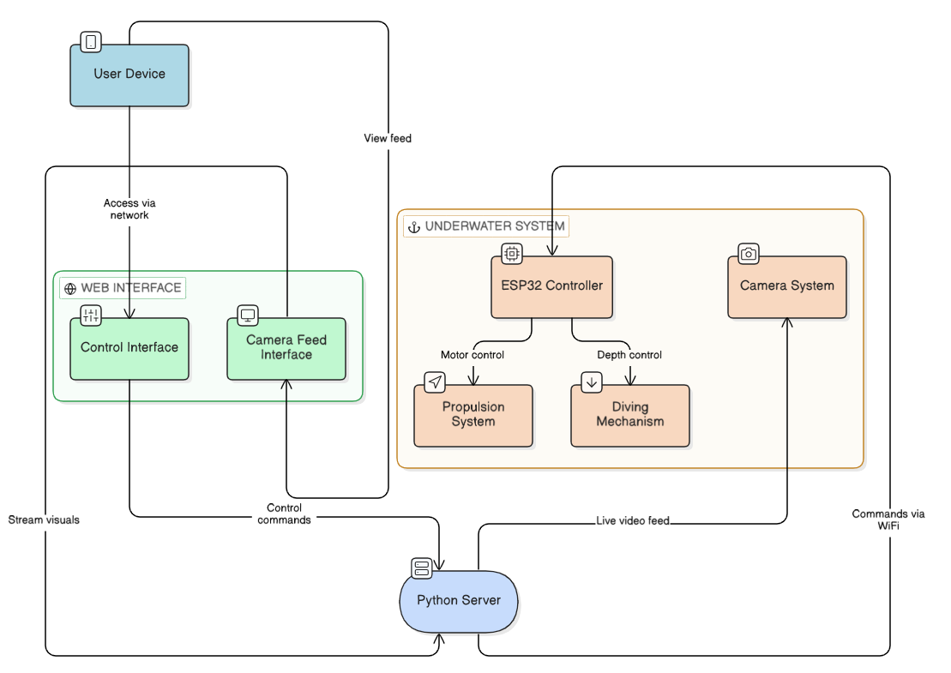

Results & Discussion:
The VOYAGER prototype was successfully designed, assembled, and tested, showing that a compact underwater ROV can perform its basic functions effectively. The system worked well in controlled environments, proving that the overall design and implementation approach are reliable.
During testing, the movement system performed smoothly. The DC motors allowed forward and backward motion, while the servo motor helped in changing direction, giving the vehicle basic maneuverability. The system responded well to control inputs, showing good coordination between the controller and motor components.
The communication system also worked as expected. Using the ESP32, a stable wireless connection was established over a local network. This allowed:
• Real-time control from the user interface
• Quick response to commands with minimal delay
• Smooth interaction between the operator and the system
The onboard camera played an important role by providing live video streaming:
• Continuous visual feedback to the operator
• Better navigation even in low-visibility conditions
• Improved monitoring and control of the vehicle
From an overall system perspective, the integration of hardware and software was successful. The modular design made it easier to build and manage the system, while the compact structure helped in easy testing and deployment.Some limitations were also observed during testing:
• Wireless communication range is limited underwater
• Signal strength may reduce due to water interference
• The system is best suited for shallow water and controlled environments
The concept of wireless charging, though mainly at the design stage, adds value to the system by:
• Reducing the need for exposed charging ports
• Improving waterproofing
• Lowering maintenance requirements
The results show that the VOYAGER system successfully achieves its main goals:
• Real-time underwater movement and control
• Stable wireless communication
• Live video monitoring
The project provides a working prototype and a strong base for further improvements and future development.

Conclusion & Future Scope:
The VOYAGER project successfully shows how a compact underwater robot (ROV) can be designed and built to perform real-time navigation using embedded systems and wireless communication. The prototype brings together important features like movement control, steering, live video streaming, and wireless operation into one complete system. This makes it a practical and cost-effective solution, especially for academic use and basic underwater exploration.
During testing, the system performed well in controlled environments. The use of the ESP32 proved effective for handling communication and control tasks. The motors provided smooth movement, the steering was responsive, and the wireless connection remained stable. The onboard camera added an important advantage by allowing live monitoring, which made controlling the system easier and more interactive. The idea of wireless charging, though still conceptual, also adds value by improving durability and reducing issues related to exposed charging ports.From an engineering point of view, the project helps in understanding how different components work together. It highlights important aspects such as:
• Integration of hardware and software
• Real-time communication and control
• Challenges in underwater environments like signal loss and power handling
At the same time, there are some limitations. The current prototype works best in controlled and shallow water conditions, and its performance can be further improved for more complex environments. These limitations create opportunities for future enhancements and further development of the system.
Future Scope:
- Enhanced Communication Systems
Explore alternative communication methods or signal optimization techniques to improve range and reliability in underwater conditions.
- Improved Structural Design and Waterproofing
Develop more robust and pressure-resistant enclosures to enable operation in deeper or more challenging environments.
- Advanced Control Interface
Design a more intuitive and feature-rich user interface, potentially including mobile application support or real-time telemetry visualization.
- Integration of Additional Sensors
Incorporate sensors such as depth, temperature, or pressure sensors to provide more comprehensive environmental data.
- Optimization of Power Management
Further refine the wireless charging system and improve battery efficiency for extended operational time.
- Autonomous or Semi-Autonomous Capabilities
Introduce basic automation features such as obstacle avoidance or path stabilization to enhance system intelligence.
- Scalability and Modular Expansion
Redesign the system to support easy addition or replacement of components, allowing future upgrades without major structural changes.

In conclusion, the VOYAGER project achieves its intended objectives and demonstrates a practical approach to underwater robotic system design. It not only serves as a functional prototype but also as a stepping stone for future innovations in compact and efficient underwater exploration technologies.

References:

T. I. Fossen, Handbook of Marine Craft Hydrodynamics and Motion Control. John Wiley & Sons, 2011.

J. Yuh, “Design and control of autonomous underwater robots: A survey,” Autonomous Robots, vol. 8, no. 1, pp. 7–24, 2000.

R. Christ and R. Wernli, The ROV Manual: A User Guide for Remotely Operated Vehicles. Elsevier, 2014.

S. M. Smith and J. S. Marr, “Development of low-cost remotely operated underwater vehicles for shallow water exploration,” International Journal of Engineering Research and Technology, vol. 6, no. 4, pp. 215–220, 2017.

Antonelli, “Underwater robots,” in Springer Handbook of Robotics, Springer, 2016, pp. 987–1008.

Espressif Systems, “ESP32-S3 Technical Reference Manual,” 2022.

Seeed Studio, “XIAO ESP32S3 Sense – Hardware Overview and Datasheet,” 2023.

Texas Instruments, “DRV8833 Dual H-Bridge Motor Driver Datasheet,” 2021.

J. Liu, J. T. Boys, and G. A. Covic, “An efficient inductive power transfer system for charging applications,” IEEE Transactions on Power Electronics, vol. 25, no. 9, pp. 2392–2401, 2010.

Y. Zhang and Z. Zhao, “Wireless power transfer technologies for underwater applications,” IEEE Access, vol. 7, pp. 177–188, 2019.

M. Doniec, M. Angermann, and D. Rus, “An end-to-end signal strength model for underwater optical communications,” IEEE Journal of Oceanic Engineering, vol. 38, no. 4, pp. 743–757, 2013.

A.Birk and S. Carpin, “Rescue robotics – A crucial milestone on the road to autonomous systems,” Advanced Robotics, vol. 20, no. 5, pp. 595–620, 2006.

Codes:
ESP 32 SYSTEM CONTROL CODE:

#include <WiFi.h>
#include <WebServer.h>
#include <ESP32Servo.h>

const char* ssid = "Amey's A35";
const char* password = "bcdh5175";

WebServer server(80);
Servo servo;

/* Motor Pins */
// Motor 1 (Forward/Backward)
int IN1 = 27;
int IN2 = 26;

// Motor 2 (Up/Down)
int IN3 = 25;
int IN4 = 33;

/* Servo Pin */
int servoPin = 14;

/* WiFi connect */
void connectWiFi() {

Serial.begin(115200);

WiFi.disconnect(true, true);
delay(2000);

WiFi.mode(WIFI_STA);
WiFi.setSleep(false);

WiFi.begin(ssid, password);

while (WiFi.status() != WL_CONNECTED) {
delay(500);
Serial.print(".");
}

Serial.println();
Serial.print("IP: ");
Serial.println(WiFi.localIP());
}

/* Web Page */
void handleRoot() {

String page = R"rawliteral(

<!DOCTYPE html>

<html>

<head>
<meta name="viewport" content="width=device-width, initial-scale=1.0">

<style>
body{
font-family:Arial;
background:#111;
color:white;
text-align:center;
margin-top:40px;
}
button{
width:120px;
height:60px;
font-size:18px;
border:none;
border-radius:10px;
margin:10px;
background:#333;
color:white;
}
button:active{
background:#00aaff;
}
.slider{
width:80%;
}
</style>

</head>

<body>

<h2>ESP32 Submarine Control</h2>

<h3>Forward Motor</h3>
<button onclick="fetch('/forward')">FORWARD</button>
<button onclick="fetch('/backward')">BACKWARD</button>
<button onclick="fetch('/stop')">STOP</button>

<h3>Vertical Control</h3>
<button onclick="fetch('/up')">UP</button>
<button onclick="fetch('/down')">DOWN</button>
<button onclick="fetch('/vstop')">STOP</button>

<h3>Servo Direction</h3>
<input type="range"
min="0"
max="180"
value="90"
class="slider"
oninput="servoMove(this.value)">

<script>
function servoMove(pos){
fetch("/servo?pos=" + pos);
}
</script>

</body>
</html>

)rawliteral";

server.send(200,"text/html",page);
}

/* -------- MOTOR 1 (FORWARD/BACKWARD) -------- */

void forward(){
digitalWrite(IN1, HIGH);
digitalWrite(IN2, LOW);
server.send(200,"text/plain","Forward");
}

void backward(){
digitalWrite(IN1, LOW);
digitalWrite(IN2, HIGH);
server.send(200,"text/plain","Backward");
}

void stopMotor(){
digitalWrite(IN1, LOW);
digitalWrite(IN2, LOW);
server.send(200,"text/plain","Stopped");
}

/* -------- MOTOR 2 (UP/DOWN) -------- */

void up(){
digitalWrite(IN3, HIGH);
digitalWrite(IN4, LOW);
server.send(200,"text/plain","Going Up");
}

void down(){
digitalWrite(IN3, LOW);
digitalWrite(IN4, HIGH);
server.send(200,"text/plain","Going Down");
}

void verticalStop(){
digitalWrite(IN3, LOW);
digitalWrite(IN4, LOW);
server.send(200,"text/plain","Vertical Stopped");
}

/* -------- SERVO -------- */

void servoControl(){
int pos = server.arg("pos").toInt();
servo.write(pos);
server.send(200,"text/plain","OK");
}

/* -------- SETUP -------- */

void setup(){

pinMode(IN1, OUTPUT);
pinMode(IN2, OUTPUT);
pinMode(IN3, OUTPUT);
pinMode(IN4, OUTPUT);

digitalWrite(IN1, LOW);
digitalWrite(IN2, LOW);
digitalWrite(IN3, LOW);
digitalWrite(IN4, LOW);

/* Servo Setup */
ESP32PWM::allocateTimer(0);
servo.attach(servoPin,500,2400);

connectWiFi();
/* Routes */
server.on("/", handleRoot);

// Forward motor
server.on("/forward", forward);
server.on("/backward", backward);
server.on("/stop", stopMotor);

// Vertical motor
server.on("/up", up);
server.on("/down", down);
server.on("/vstop", verticalStop);

// Servo
server.on("/servo", servoControl);

server.begin();

Serial.println("Server Started");
}

/* -------- LOOP -------- */

void loop(){
server.handleClient();
}

Python server control CODE:

from flask import Flask, request, send_from_directory
import serial

app = Flask(__name__)

esp = serial.Serial('COM3', 115200, timeout=1)

@app.route('/')
def index():
return send_from_directory('.', 'index.html')

@app.route('/forward')
def forward():
esp.write(b'F\n')
return "OK"

@app.route('/backward')
def backward():
esp.write(b'B\n')
return "OK"

@app.route('/stop')
def stop():
esp.write(b'S\n')
return "OK"

@app.route('/up')
def up():
esp.write(b'U\n')
return "OK"

@app.route('/down')
def down():
esp.write(b'D\n')
return "OK"

@app.route('/vstop')
def vstop():
esp.write(b'VS\n')
return "OK"

@app.route('/servo')
def servo():
pos = request.args.get('pos')
command = f"SERVO:{pos}\n"
esp.write(command.encode())
return "OK"

app.run(host='0.0.0.0', port=5000)

Images and Visuals:
